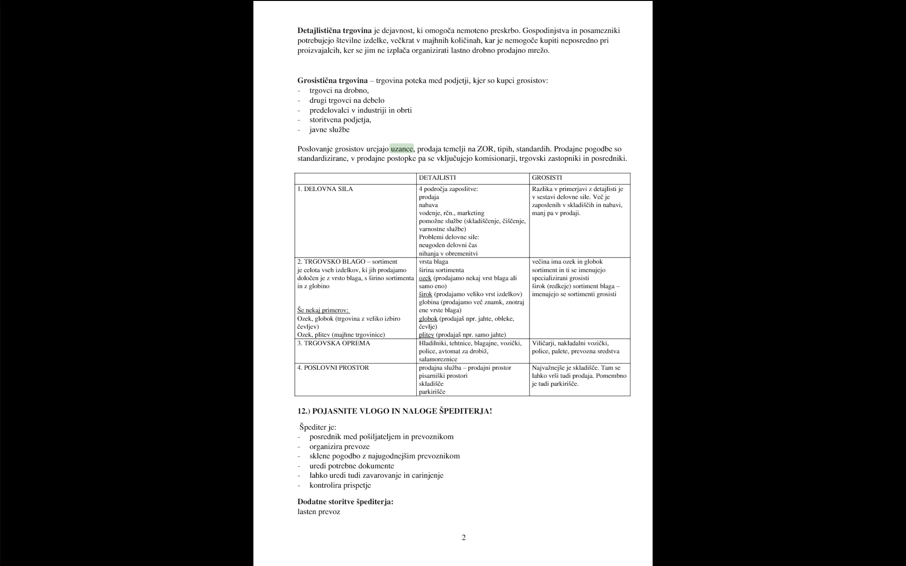



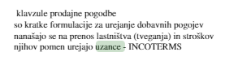

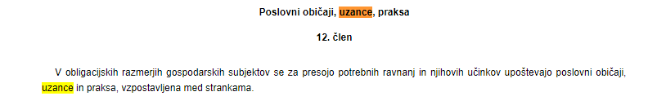

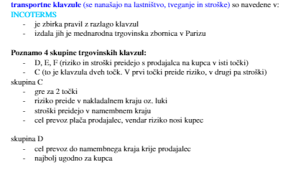

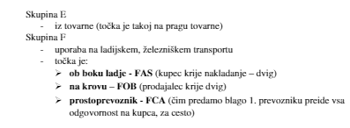

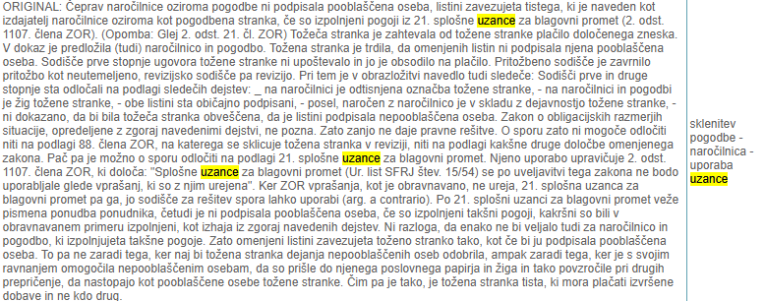

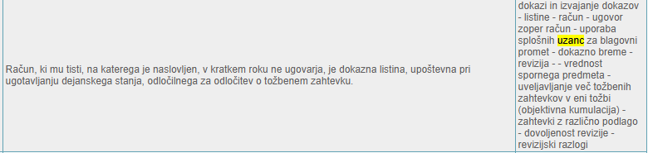

<http://www.pisrs.si/Pis.web/pregledPredpisaSodnaPraksa?id=ZAKO1364&loadAll=true&page=2&izbranClen=1107>

<http://www.podaci.com/_z1/2125837/O-uprobo02v5415.html>

<https://translate.google.si/translate?sl=hr&tl=sl&js=y&prev=_t&hl=sl&ie=UTF-8&u=http%3A%2F%2Fwww.podaci.com%2F_z1%2F2125837%2FO-uprobo02v5415.html&edit-text=&act=url>

<https://www.uradni-list.si/glasilo-uradni-list-rs/vsebina/111822> Uzance vračljiva embalaža

