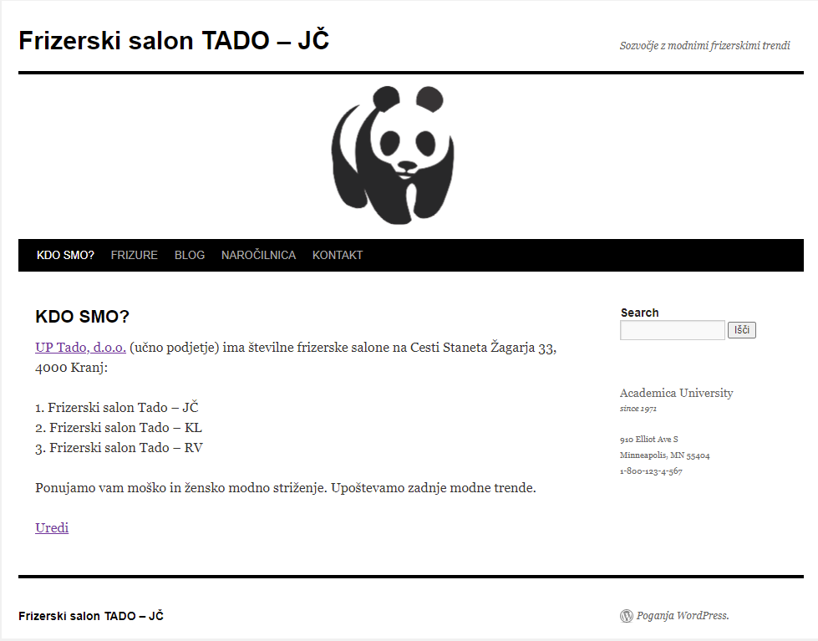

<!-- wp:paragraph -->

<p><a href="https://lebinca.com/uptado" target="_blank" rel="noreferrer noopener">UP Tado, d.o.o.</a> (učno podjetje) ima številne frizerske salone na Cesti Staneta Žagarja 33, 4000 Kranj:</p>

<!-- /wp:paragraph -->

<!-- wp:paragraph -->

<p>1. Frizerski salon Tado - JČ<br>2. Frizerski salon Tado - KL<br>3. Frizerski salon Tado - RV</p>

<!-- /wp:paragraph -->

<!-- wp:paragraph -->

<p>Ponujamo vam moško in žensko modno striženje. Upoštevamo zadnje modne trende.</p>

<!-- /wp:paragraph -->

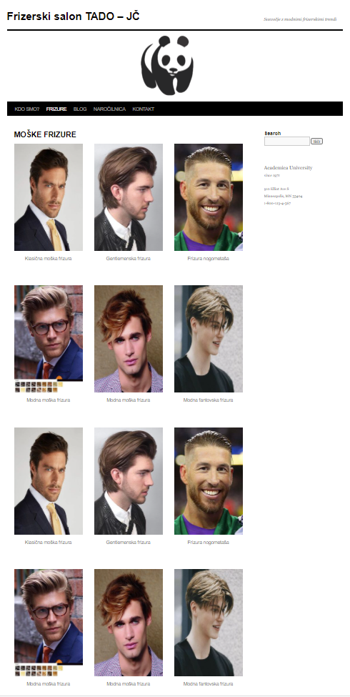

<!-- wp:columns -->

<div class="wp-block-columns"><!-- wp:column -->

<div class="wp-block-column"><!-- wp:image {"id":78,"sizeSlug":"medium","linkDestination":"none"} -->

<figure class="wp-block-image size-medium"><img src="https://fstadojc.splet.arnes.si/files/2022/01/1-klasicne-moske-233x300.jpg" alt="" class="wp-image-78"/><figcaption>Klasična moška frizura</figcaption></figure>

<!-- /wp:image --></div>

<!-- /wp:column -->

<!-- wp:column -->

<div class="wp-block-column"><!-- wp:image {"id":79,"sizeSlug":"medium","linkDestination":"none"} -->

<figure class="wp-block-image size-medium"><img src="https://fstadojc.splet.arnes.si/files/2022/01/2-gentelmenska-frizura-203x300.jpg" alt="" class="wp-image-79"/><figcaption>Gentlemenska frizura</figcaption></figure>

<!-- /wp:image --></div>

<!-- /wp:column -->

<!-- wp:column -->

<div class="wp-block-column"><!-- wp:image {"id":81,"sizeSlug":"medium","linkDestination":"none"} -->

<figure class="wp-block-image size-medium"><img src="https://fstadojc.splet.arnes.si/files/2022/01/3-nogometaska-frizura-200x300.jpg" alt="" class="wp-image-81"/><figcaption>Frizura nogometaša</figcaption></figure>

<!-- /wp:image --></div>

<!-- /wp:column --></div>

<!-- /wp:columns -->

<!-- wp:columns -->

<div class="wp-block-columns"><!-- wp:column -->

<div class="wp-block-column"><!-- wp:image {"id":82,"sizeSlug":"medium","linkDestination":"none"} -->

<figure class="wp-block-image size-medium"><img src="https://fstadojc.splet.arnes.si/files/2022/01/4-modne-moske-frizure-200x300.jpg" alt="" class="wp-image-82"/><figcaption>Modna moška frizura</figcaption></figure>

<!-- /wp:image --></div>

<!-- /wp:column -->

<!-- wp:column -->

<div class="wp-block-column"><!-- wp:image {"id":85,"sizeSlug":"medium","linkDestination":"none"} -->

<figure class="wp-block-image size-medium"><img src="https://fstadojc.splet.arnes.si/files/2022/01/5-5-modne-fantovske-237x300.jpg" alt="" class="wp-image-85"/><figcaption>Modna moška frizura</figcaption></figure>

<!-- /wp:image -->

<!-- wp:paragraph -->

<p></p>

<!-- /wp:paragraph --></div>

<!-- /wp:column -->

<!-- wp:column -->

<div class="wp-block-column"><!-- wp:image {"id":84,"sizeSlug":"medium","linkDestination":"none"} -->

<figure class="wp-block-image size-medium"><img src="https://fstadojc.splet.arnes.si/files/2022/01/6-modne-fantovske-dolge-frizure-243x300.jpg" alt="" class="wp-image-84"/><figcaption>Modna fantovska frizura</figcaption></figure>

<!-- /wp:image -->

<!-- wp:paragraph -->

<p></p>

<!-- /wp:paragraph --></div>

<!-- /wp:column --></div>

<!-- /wp:columns -->

<!-- wp:columns -->

<div class="wp-block-columns"><!-- wp:column -->

<div class="wp-block-column"><!-- wp:image {"id":78,"sizeSlug":"medium","linkDestination":"none"} -->

<figure class="wp-block-image size-medium"><img src="https://fstadojc.splet.arnes.si/files/2022/01/1-klasicne-moske-233x300.jpg" alt="" class="wp-image-78"/><figcaption>Klasična moška frizura</figcaption></figure>

<!-- /wp:image --></div>

<!-- /wp:column -->

<!-- wp:column -->

<div class="wp-block-column"><!-- wp:image {"id":79,"sizeSlug":"medium","linkDestination":"none"} -->

<figure class="wp-block-image size-medium"><img src="https://fstadojc.splet.arnes.si/files/2022/01/2-gentelmenska-frizura-203x300.jpg" alt="" class="wp-image-79"/><figcaption>Gentlemenska frizura</figcaption></figure>

<!-- /wp:image --></div>

<!-- /wp:column -->

<!-- wp:column -->

<div class="wp-block-column"><!-- wp:image {"id":81,"sizeSlug":"medium","linkDestination":"none"} -->

<figure class="wp-block-image size-medium"><img src="https://fstadojc.splet.arnes.si/files/2022/01/3-nogometaska-frizura-200x300.jpg" alt="" class="wp-image-81"/><figcaption>Frizura nogometaša</figcaption></figure>

<!-- /wp:image --></div>

<!-- /wp:column --></div>

<!-- /wp:columns -->

<!-- wp:columns -->

<div class="wp-block-columns"><!-- wp:column -->

<div class="wp-block-column"><!-- wp:image {"id":82,"sizeSlug":"medium","linkDestination":"none"} -->

<figure class="wp-block-image size-medium"><img src="https://fstadojc.splet.arnes.si/files/2022/01/4-modne-moske-frizure-200x300.jpg" alt="" class="wp-image-82"/><figcaption>Modna moška frizura</figcaption></figure>

<!-- /wp:image --></div>

<!-- /wp:column -->

<!-- wp:column -->

<div class="wp-block-column"><!-- wp:image {"id":85,"sizeSlug":"medium","linkDestination":"none"} -->

<figure class="wp-block-image size-medium"><img src="https://fstadojc.splet.arnes.si/files/2022/01/5-5-modne-fantovske-237x300.jpg" alt="" class="wp-image-85"/><figcaption>Modna moška frizura</figcaption></figure>

<!-- /wp:image -->

<!-- wp:paragraph -->

<p></p>

<!-- /wp:paragraph --></div>

<!-- /wp:column -->

<!-- wp:column -->

<div class="wp-block-column"><!-- wp:image {"id":84,"sizeSlug":"medium","linkDestination":"none"} -->

<figure class="wp-block-image size-medium"><img src="https://fstadojc.splet.arnes.si/files/2022/01/6-modne-fantovske-dolge-frizure-243x300.jpg" alt="" class="wp-image-84"/><figcaption>Modna fantovska frizura</figcaption></figure>

<!-- /wp:image -->

<!-- wp:paragraph -->

<p></p>

<!-- /wp:paragraph --></div>

<!-- /wp:column --></div>

<!-- /wp:columns -->

<!-- wp:columns -->

<div class="wp-block-columns"><!-- wp:column -->

<div class="wp-block-column"><!-- wp:image {"id":78,"sizeSlug":"medium","linkDestination":"none"} -->

<figure class="wp-block-image size-medium"><img src="https://fstadojc.splet.arnes.si/files/2022/01/1-klasicne-moske-233x300.jpg" alt="" class="wp-image-78"/><figcaption>Klasična moška frizura</figcaption></figure>

<!-- /wp:image --></div>

<!-- /wp:column -->

<!-- wp:column -->

<div class="wp-block-column"><!-- wp:image {"id":79,"sizeSlug":"medium","linkDestination":"none"} -->

<figure class="wp-block-image size-medium"><img src="https://fstadojc.splet.arnes.si/files/2022/01/2-gentelmenska-frizura-203x300.jpg" alt="" class="wp-image-79"/><figcaption>Gentlemenska frizura</figcaption></figure>

<!-- /wp:image --></div>

<!-- /wp:column -->

<!-- wp:column -->

<div class="wp-block-column"><!-- wp:image {"id":81,"sizeSlug":"medium","linkDestination":"none"} -->

<figure class="wp-block-image size-medium"><img src="https://fstadojc.splet.arnes.si/files/2022/01/3-nogometaska-frizura-200x300.jpg" alt="" class="wp-image-81"/><figcaption>Frizura nogometaša</figcaption></figure>

<!-- /wp:image --></div>

<!-- /wp:column --></div>

<!-- /wp:columns -->

<!-- wp:columns -->

<div class="wp-block-columns"><!-- wp:column -->

<div class="wp-block-column"><!-- wp:image {"id":82,"sizeSlug":"medium","linkDestination":"none"} -->

<figure class="wp-block-image size-medium"><img src="https://fstadojc.splet.arnes.si/files/2022/01/4-modne-moske-frizure-200x300.jpg" alt="" class="wp-image-82"/><figcaption>Modna moška frizura</figcaption></figure>

<!-- /wp:image --></div>

<!-- /wp:column -->

<!-- wp:column -->

<div class="wp-block-column"><!-- wp:image {"id":85,"sizeSlug":"medium","linkDestination":"none"} -->

<figure class="wp-block-image size-medium"><img src="https://fstadojc.splet.arnes.si/files/2022/01/5-5-modne-fantovske-237x300.jpg" alt="" class="wp-image-85"/><figcaption>Modna moška frizura</figcaption></figure>

<!-- /wp:image -->

<!-- wp:paragraph -->

<p></p>

<!-- /wp:paragraph --></div>

<!-- /wp:column -->

<!-- wp:column -->

<div class="wp-block-column"><!-- wp:image {"id":84,"sizeSlug":"medium","linkDestination":"none"} -->

<figure class="wp-block-image size-medium"><img src="https://fstadojc.splet.arnes.si/files/2022/01/6-modne-fantovske-dolge-frizure-243x300.jpg" alt="" class="wp-image-84"/><figcaption>Modna fantovska frizura</figcaption></figure>

<!-- /wp:image -->

<!-- wp:paragraph -->

<p></p>

<!-- /wp:paragraph --></div>

<!-- /wp:column --></div>

<!-- /wp:columns -->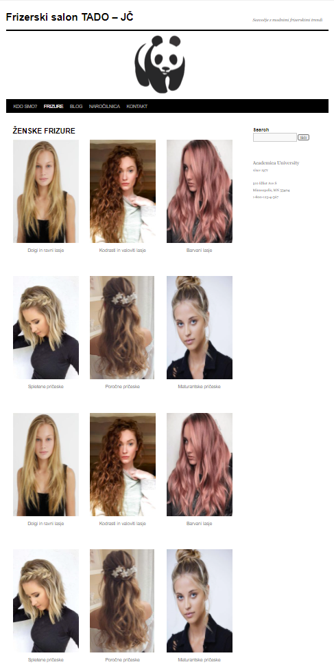

<!-- wp:columns -->

<div class="wp-block-columns"><!-- wp:column -->

<div class="wp-block-column"><!-- wp:image {"id":41,"sizeSlug":"medium","linkDestination":"none"} -->

<figure class="wp-block-image size-medium"><img src="https://fstadojc.splet.arnes.si/files/2022/01/1-dolge-lasje-221x300.jpg" alt="" class="wp-image-41"/><figcaption>Dolgi in ravni lasje</figcaption></figure>

<!-- /wp:image --></div>

<!-- /wp:column -->

<!-- wp:column -->

<div class="wp-block-column"><!-- wp:image {"id":71,"sizeSlug":"medium","linkDestination":"none"} -->

<figure class="wp-block-image size-medium"><img src="https://fstadojc.splet.arnes.si/files/2022/01/2-2-kodrasti-lasje-213x300.jpg" alt="" class="wp-image-71"/><figcaption>Kodrasti in valoviti lasje</figcaption></figure>

<!-- /wp:image --></div>

<!-- /wp:column -->

<!-- wp:column -->

<div class="wp-block-column"><!-- wp:image {"id":54,"sizeSlug":"medium","linkDestination":"none"} -->

<figure class="wp-block-image size-medium"><img src="https://fstadojc.splet.arnes.si/files/2022/01/3-barvani-lasje-234x300.jpg" alt="" class="wp-image-54"/><figcaption>Barvani lasje</figcaption></figure>

<!-- /wp:image --></div>

<!-- /wp:column --></div>

<!-- /wp:columns -->

<!-- wp:columns -->

<div class="wp-block-columns"><!-- wp:column -->

<div class="wp-block-column"><!-- wp:image {"id":55,"sizeSlug":"medium","linkDestination":"none"} -->

<figure class="wp-block-image size-medium"><img src="https://fstadojc.splet.arnes.si/files/2022/01/4-spletene-priceske-210x300.jpg" alt="" class="wp-image-55"/><figcaption>Spletene pričeske</figcaption></figure>

<!-- /wp:image --></div>

<!-- /wp:column -->

<!-- wp:column -->

<div class="wp-block-column"><!-- wp:image {"id":56,"sizeSlug":"medium","linkDestination":"none"} -->

<figure class="wp-block-image size-medium"><img src="https://fstadojc.splet.arnes.si/files/2022/01/5-porocne-priceske-189x300.jpg" alt="" class="wp-image-56"/><figcaption>Poročne pričeske</figcaption></figure>

<!-- /wp:image -->

<!-- wp:paragraph -->

<p></p>

<!-- /wp:paragraph --></div>

<!-- /wp:column -->

<!-- wp:column -->

<div class="wp-block-column"><!-- wp:image {"id":57,"sizeSlug":"medium","linkDestination":"none"} -->

<figure class="wp-block-image size-medium"><img src="https://fstadojc.splet.arnes.si/files/2022/01/6-maturantske-priceske-240x300.jpg" alt="" class="wp-image-57"/><figcaption>Maturantske pričeske</figcaption></figure>

<!-- /wp:image -->

<!-- wp:paragraph -->

<p></p>

<!-- /wp:paragraph --></div>

<!-- /wp:column --></div>

<!-- /wp:columns -->

<!-- wp:columns -->

<div class="wp-block-columns"><!-- wp:column -->

<div class="wp-block-column"><!-- wp:image {"id":41,"sizeSlug":"medium","linkDestination":"custom"} -->

<figure class="wp-block-image size-medium"><a href="https://fstadojc.splet.arnes.si/dolgi-in-ravni-lasje/" target="_blank" rel="noopener"><img src="https://fstadojc.splet.arnes.si/files/2022/01/1-dolge-lasje-221x300.jpg" alt="" class="wp-image-41"/></a><figcaption>Dolgi in ravni lasje</figcaption></figure>

<!-- /wp:image --></div>

<!-- /wp:column -->

<!-- wp:column -->

<div class="wp-block-column"><!-- wp:image {"id":71,"sizeSlug":"medium","linkDestination":"none"} -->

<figure class="wp-block-image size-medium"><img src="https://fstadojc.splet.arnes.si/files/2022/01/2-2-kodrasti-lasje-213x300.jpg" alt="" class="wp-image-71"/><figcaption>Kodrasti in valoviti lasje</figcaption></figure>

<!-- /wp:image --></div>

<!-- /wp:column -->

<!-- wp:column -->

<div class="wp-block-column"><!-- wp:image {"id":54,"sizeSlug":"medium","linkDestination":"none"} -->

<figure class="wp-block-image size-medium"><img src="https://fstadojc.splet.arnes.si/files/2022/01/3-barvani-lasje-234x300.jpg" alt="" class="wp-image-54"/><figcaption>Barvani lasje</figcaption></figure>

<!-- /wp:image --></div>

<!-- /wp:column --></div>

<!-- /wp:columns -->

<!-- wp:columns -->

<div class="wp-block-columns"><!-- wp:column -->

<div class="wp-block-column"><!-- wp:image {"id":55,"sizeSlug":"medium","linkDestination":"none"} -->

<figure class="wp-block-image size-medium"><img src="https://fstadojc.splet.arnes.si/files/2022/01/4-spletene-priceske-210x300.jpg" alt="" class="wp-image-55"/><figcaption>Spletene pričeske</figcaption></figure>

<!-- /wp:image --></div>

<!-- /wp:column -->

<!-- wp:column -->

<div class="wp-block-column"><!-- wp:image {"id":56,"sizeSlug":"medium","linkDestination":"none"} -->

<figure class="wp-block-image size-medium"><img src="https://fstadojc.splet.arnes.si/files/2022/01/5-porocne-priceske-189x300.jpg" alt="" class="wp-image-56"/><figcaption>Poročne pričeske</figcaption></figure>

<!-- /wp:image -->

<!-- wp:paragraph -->

<p></p>

<!-- /wp:paragraph --></div>

<!-- /wp:column -->

<!-- wp:column -->

<div class="wp-block-column"><!-- wp:image {"id":57,"sizeSlug":"medium","linkDestination":"none"} -->

<figure class="wp-block-image size-medium"><img src="https://fstadojc.splet.arnes.si/files/2022/01/6-maturantske-priceske-240x300.jpg" alt="" class="wp-image-57"/><figcaption>Maturantske pričeske</figcaption></figure>

<!-- /wp:image -->

<!-- wp:paragraph -->

<p></p>

<!-- /wp:paragraph --></div>

<!-- /wp:column --></div>

<!-- /wp:columns -->

<!-- wp:columns -->

<div class="wp-block-columns"><!-- wp:column -->

<div class="wp-block-column"><!-- wp:image {"id":41,"sizeSlug":"medium","linkDestination":"custom"} -->

<figure class="wp-block-image size-medium"><a href="https://fstadojc.splet.arnes.si/dolgi-in-ravni-lasje/" target="_blank" rel="noopener"><img src="https://fstadojc.splet.arnes.si/files/2022/01/1-dolge-lasje-221x300.jpg" alt="" class="wp-image-41"/></a><figcaption>Dolgi in ravni lasje</figcaption></figure>

<!-- /wp:image --></div>

<!-- /wp:column -->

<!-- wp:column -->

<div class="wp-block-column"><!-- wp:image {"id":71,"sizeSlug":"medium","linkDestination":"none"} -->

<figure class="wp-block-image size-medium"><img src="https://fstadojc.splet.arnes.si/files/2022/01/2-2-kodrasti-lasje-213x300.jpg" alt="" class="wp-image-71"/><figcaption>Kodrasti in valoviti lasje</figcaption></figure>

<!-- /wp:image --></div>

<!-- /wp:column -->

<!-- wp:column -->

<div class="wp-block-column"><!-- wp:image {"id":54,"sizeSlug":"medium","linkDestination":"none"} -->

<figure class="wp-block-image size-medium"><img src="https://fstadojc.splet.arnes.si/files/2022/01/3-barvani-lasje-234x300.jpg" alt="" class="wp-image-54"/><figcaption>Barvani lasje</figcaption></figure>

<!-- /wp:image --></div>

<!-- /wp:column --></div>

<!-- /wp:columns -->

<!-- wp:columns -->

<div class="wp-block-columns"><!-- wp:column -->

<div class="wp-block-column"><!-- wp:image {"id":55,"sizeSlug":"medium","linkDestination":"none"} -->

<figure class="wp-block-image size-medium"><img src="https://fstadojc.splet.arnes.si/files/2022/01/4-spletene-priceske-210x300.jpg" alt="" class="wp-image-55"/><figcaption>Spletene pričeske</figcaption></figure>

<!-- /wp:image --></div>

<!-- /wp:column -->

<!-- wp:column -->

<div class="wp-block-column"><!-- wp:image {"id":56,"sizeSlug":"medium","linkDestination":"none"} -->

<figure class="wp-block-image size-medium"><img src="https://fstadojc.splet.arnes.si/files/2022/01/5-porocne-priceske-189x300.jpg" alt="" class="wp-image-56"/><figcaption>Poročne pričeske</figcaption></figure>

<!-- /wp:image -->

<!-- wp:paragraph -->

<p></p>

<!-- /wp:paragraph --></div>

<!-- /wp:column -->

<!-- wp:column -->

<div class="wp-block-column"><!-- wp:image {"id":57,"sizeSlug":"medium","linkDestination":"none"} -->

<figure class="wp-block-image size-medium"><img src="https://fstadojc.splet.arnes.si/files/2022/01/6-maturantske-priceske-240x300.jpg" alt="" class="wp-image-57"/><figcaption>Maturantske pričeske</figcaption></figure>

<!-- /wp:image -->

<!-- wp:paragraph -->

<p></p>

<!-- /wp:paragraph --></div>

<!-- /wp:column --></div>

<!-- /wp:columns -->

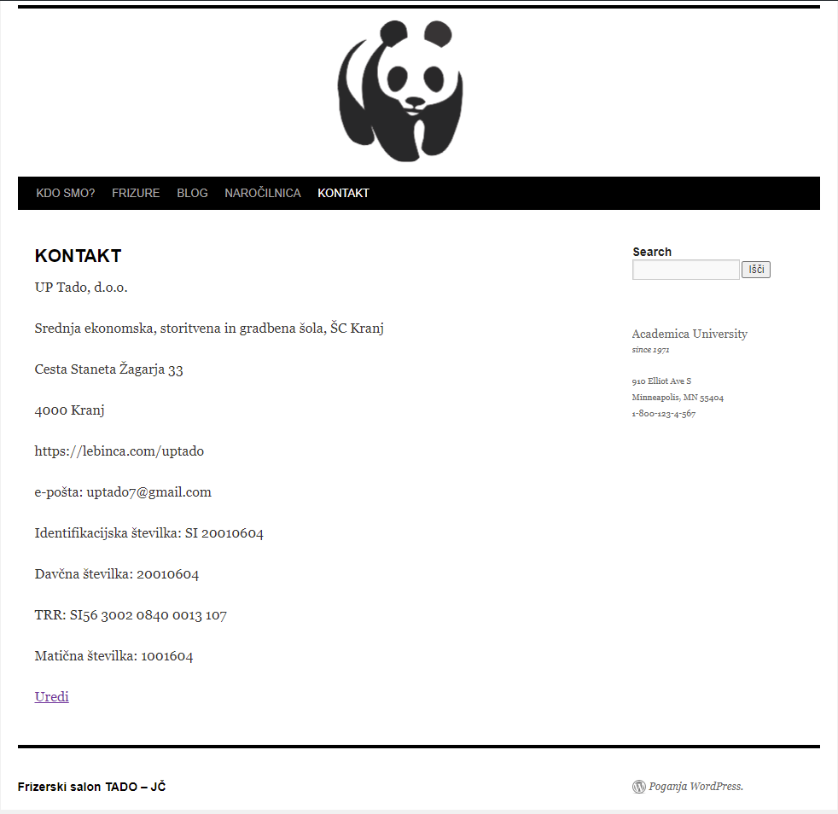

<!-- wp:paragraph -->

<p>UP Tado, d.o.o.</p>

<!-- /wp:paragraph -->

<!-- wp:paragraph -->

<p>Srednja ekonomska, storitvena in gradbena šola, ŠC Kranj</p>

<!-- /wp:paragraph -->

<!-- wp:paragraph -->

<p>Cesta Staneta Žagarja 33</p>

<!-- /wp:paragraph -->

<!-- wp:paragraph -->

<p>4000 Kranj</p>

<!-- /wp:paragraph -->

<!-- wp:paragraph -->

<p>https://lebinca.com/uptado</p>

<!-- /wp:paragraph -->

<!-- wp:paragraph -->

<p>e-pošta: uptado7@gmail.com</p>

<!-- /wp:paragraph -->

<!-- wp:paragraph -->

<p>Identifikacijska številka: SI 20010604</p>

<!-- /wp:paragraph -->

<!-- wp:paragraph -->

<p>Davčna številka: 20010604</p>

<!-- /wp:paragraph -->

<!-- wp:paragraph -->

<p>TRR: SI56 3002 0840 0013 107</p>

<!-- /wp:paragraph -->

<!-- wp:paragraph -->

<p>Matična številka: 1001604</p>

<!-- /wp:paragraph -->

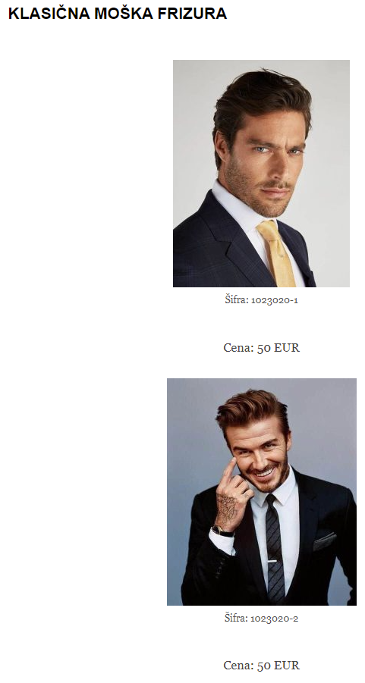

<!-- wp:image {"align":"center","id":88,"sizeSlug":"medium","linkDestination":"none"} -->

<div class="wp-block-image"><figure class="aligncenter size-medium"><img src="https://fstadojc.splet.arnes.si/files/2022/01/1-klasicne-moske-1-233x300.jpg" alt="" class="wp-image-88"/><figcaption>Šifra: 1023020-1</figcaption></figure></div>

<!-- /wp:image -->

<!-- wp:paragraph {"align":"center"} -->

<p class="has-text-align-center">Cena: 50 EUR</p>

<!-- /wp:paragraph -->

<!-- wp:image {"align":"center","id":89,"sizeSlug":"medium","linkDestination":"none"} -->

<div class="wp-block-image"><figure class="aligncenter size-medium"><img src="https://fstadojc.splet.arnes.si/files/2022/01/1-1-klasicne-moske-250x300.jpg" alt="" class="wp-image-89"/><figcaption>Šifra: 1023020-2</figcaption></figure></div>

<!-- /wp:image -->

<!-- wp:paragraph {"align":"center"} -->

<p class="has-text-align-center">Cena: 50 EUR</p>

<!-- /wp:paragraph -->

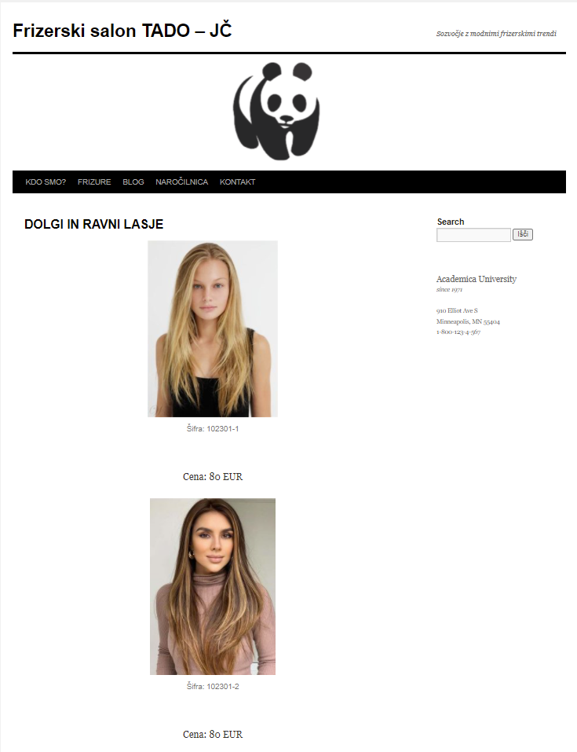

<!-- wp:image {"align":"center","id":60,"sizeSlug":"medium","linkDestination":"none"} -->

<div class="wp-block-image"><figure class="aligncenter size-medium"><img src="https://fstadojc.splet.arnes.si/files/2022/01/1-dolge-lasje-8-221x300.jpg" alt="" class="wp-image-60"/><figcaption>Šifra: 102301-1</figcaption></figure></div>

<!-- /wp:image -->

<!-- wp:paragraph {"align":"center"} -->

<p class="has-text-align-center">Cena: 80 EUR</p>

<!-- /wp:paragraph -->

<!-- wp:image {"align":"center","id":68,"sizeSlug":"medium","linkDestination":"none"} -->

<div class="wp-block-image"><figure class="aligncenter size-medium"><img src="https://fstadojc.splet.arnes.si/files/2022/01/1-1-dolge-lasje-rjavolaska-213x300.jpg" alt="" class="wp-image-68"/><figcaption>Šifra: 102301-2</figcaption></figure></div>

<!-- /wp:image -->

<!-- wp:paragraph {"align":"center"} -->

<p class="has-text-align-center">Cena: 80 EUR</p>

<!-- /wp:paragraph -->